**Supplemental Material for**

**Gill ionocyte remodeling mediates blood pH regulation in** **rockfish (*Sebastes diploproa*)exposed to environmentally relevant hypercapnia**

DOI: 10.1101/2024.05.13.593928

**Table S1:** General RNAseq analysis metrics in splitnose rockfish (*Sebastes diploproa*) pre- and post- quality control.

|  |
| --- |
|  |

**Table S2:** Differentially expressed genes in gills from rockfish that were upregulated following ERH exposure.

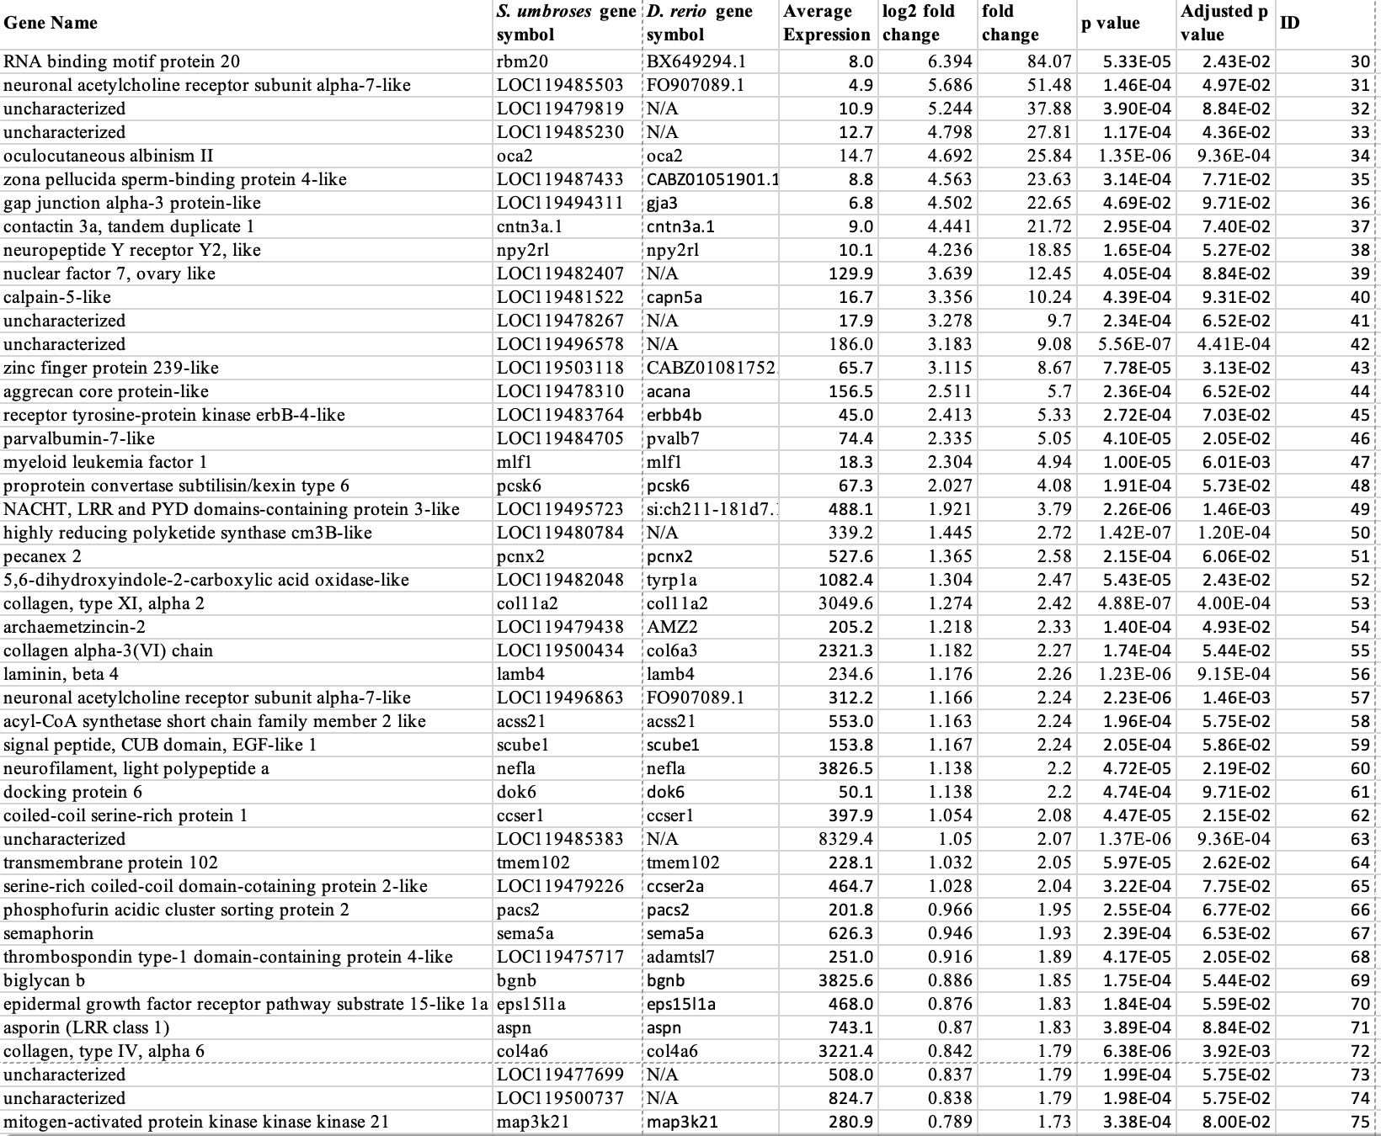 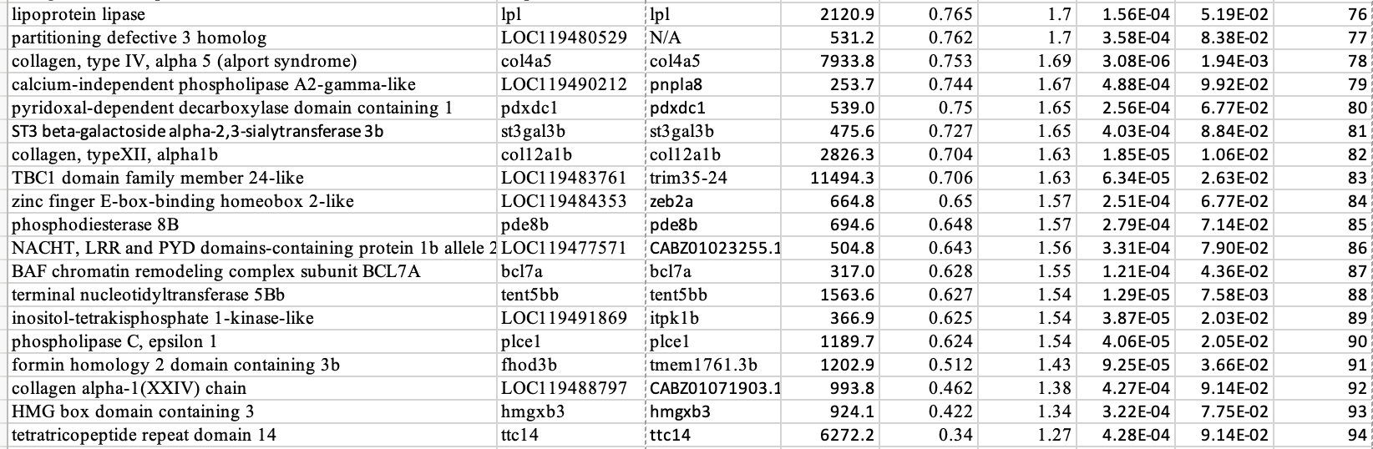

**Table S3:** Differentially expressed genes in gills from rockfish that were downregulated following ERH exposure.

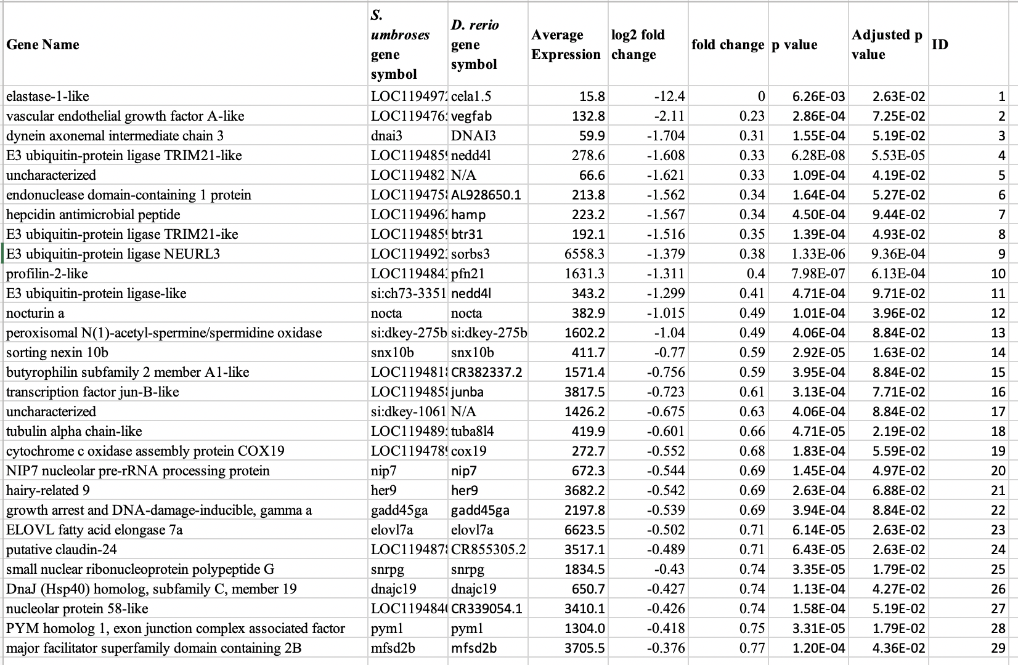

|  |  |  |  |  |  |  |  |  |  |  |  |  |  |  |  |  |  |  |  |  |  |  |  |  |  |  |  |  |
| --- | --- | --- | --- | --- | --- | --- | --- | --- | --- | --- | --- | --- | --- | --- | --- | --- | --- | --- | --- | --- | --- | --- | --- | --- | --- | --- | --- | --- |
| **Table S4: Number of Na+/K+-ATPase-rich (NKA-rich) ionocytes and v-type H+-ATPase-rich (VHA-rich) cells along the lamellae in different sections of gill filaments from control and ERH rockfish**. Values are mean ± S.E.M. N=9. Letters denote a significant difference in NKA-rich ionocyte abundance between filament sections; there were no significant differences between VHA-rich cells or between control and ERH treatments for either cell type. The data in this Table corresponds to Figure 3.   |  |  |  |  |  |  |  | | --- | --- | --- | --- | --- | --- | --- | |  | Control | | | ERH | | | | Filament section | Proximal | Medial | Distal | Proximal | Medial | Distal | | NKA-rich Ionocyte | 8.2±0.4A | 9.0±0.6A | 5.8±0.5B | 8.0±0.4A | 8.5±0.5 A | 5.0±0.4B | | VHA-rich Cell | 3.5±0.2 | 3.9±0.2 | 3.9±0.2 | 3.4±0.2 | 3.8±0.2 | 3.2±0.2 | |

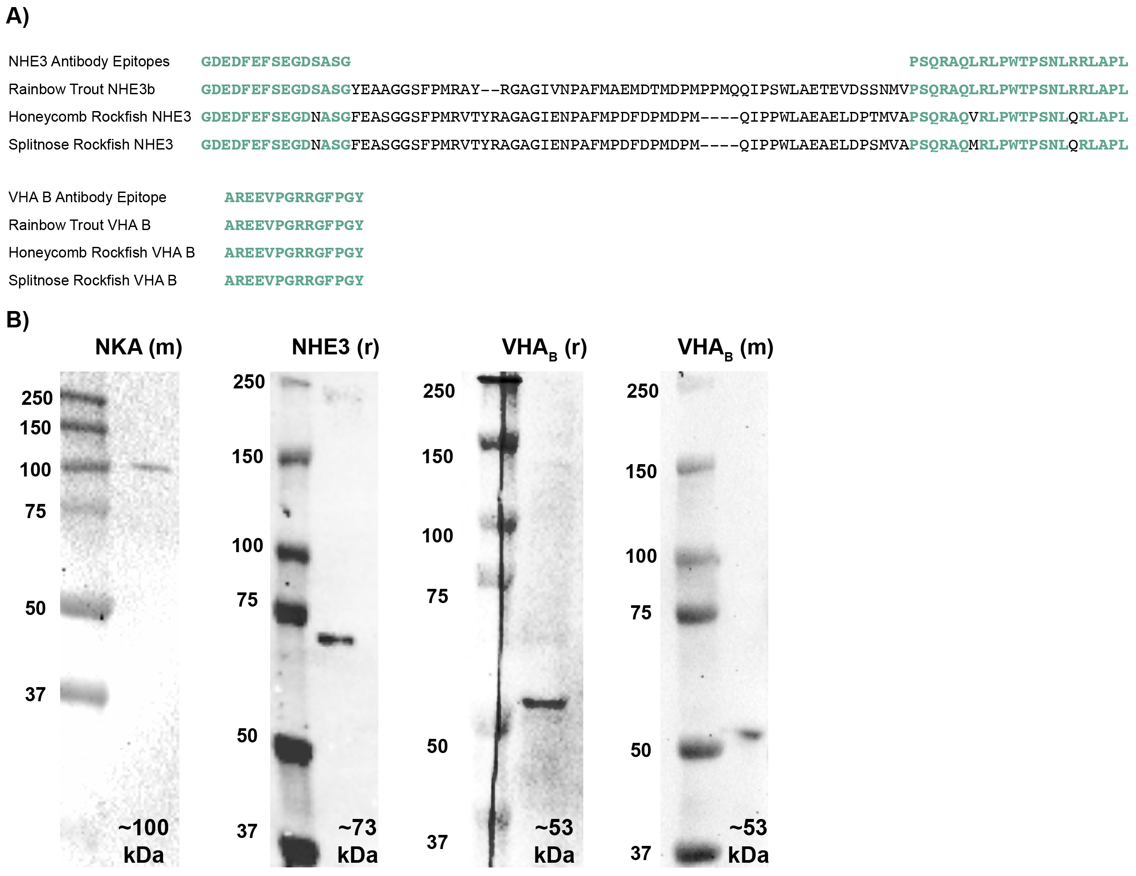

**Figure S1: Antibody validation. A)** Epitope regions (in green) recognized by the anti-NHE3 and anti-VHAB antibodies; notice the high conservation in splitnose rockfish. **B)** Western blotting on gill homogenates detected distinct bands matching the predicted size of each protein. NKA (m): mouse monoclonal antibody against Na+-K+-ATPase subunit α; NHE3 (r): rabbit polyclonal antibodies against rainbow trout NHE3; VHAB (r): rabbit polyclonal antibodies against VHA subunit B; VHA (m): mouse monoclonal antibody against VHAB. See Methods for more details about the antibodies.

|  |
| --- |
|  |

|  |
| --- |
| **Figure S2:** **Expression of acid-base relevant genes in gills from control and ERH rockfish.** FPKM: Fragments Per Kilobase of transcript per Million mapped reads. CA: carbonic anhydrase, NBC: Na+/HCO3- co-transporter (slc4a4a), βNHE: beta-Na+/H+ exchanger (slc9a1b), Pendrin: Cl-/HCO3- exchanger (slc26a4). Values are mean ± standard error of the mean. N=6. |

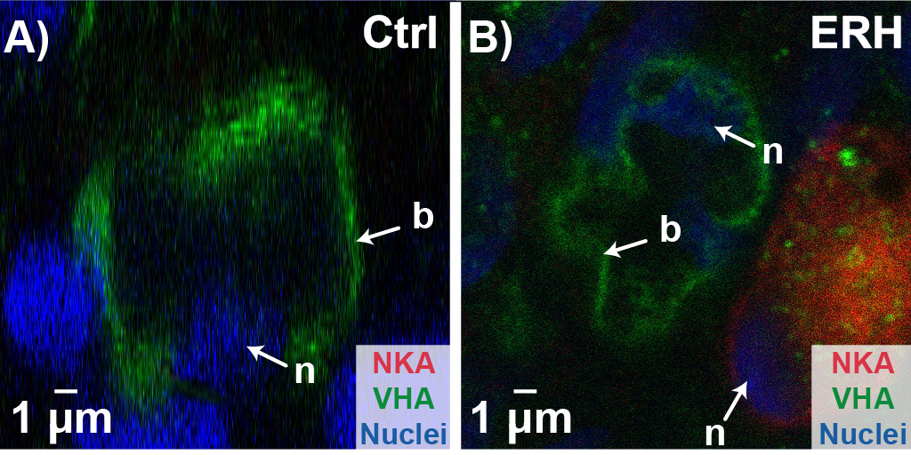

**Supplemental Figure 3**: **Protein localization in gill VHA-rich cells from control and ERH rockfish.** V-type H+ ATPase (VHA) expression within VHA-rich cells after exposure to A) control (ctrl) or B) environmentally relevant hypercapnia (ERH) conditions. NKA: Na+/K+-ATPase.

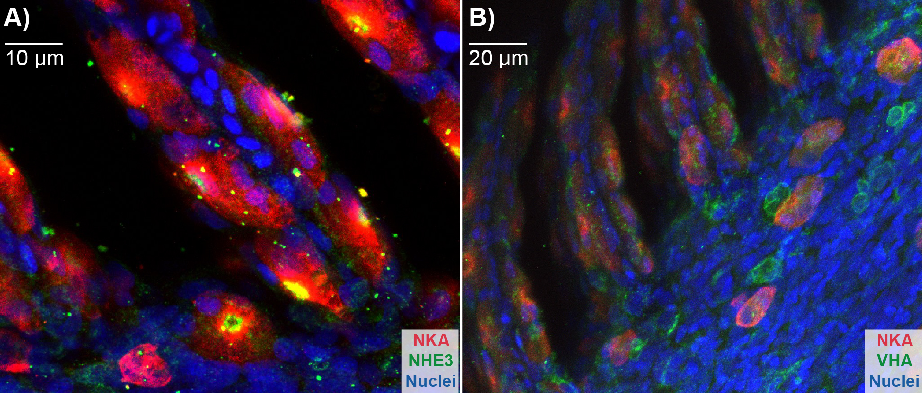

**Supplemental Figure 4**: **Protein localization in control splitnose rockfish gill.** A) Na+/K+-ATPase (NKA) and Na+/H+ exchanger 3 (NHE3) expression, and B) NKA and V-type H+ ATPase (VHA) expression within splitnose rockfish gill.

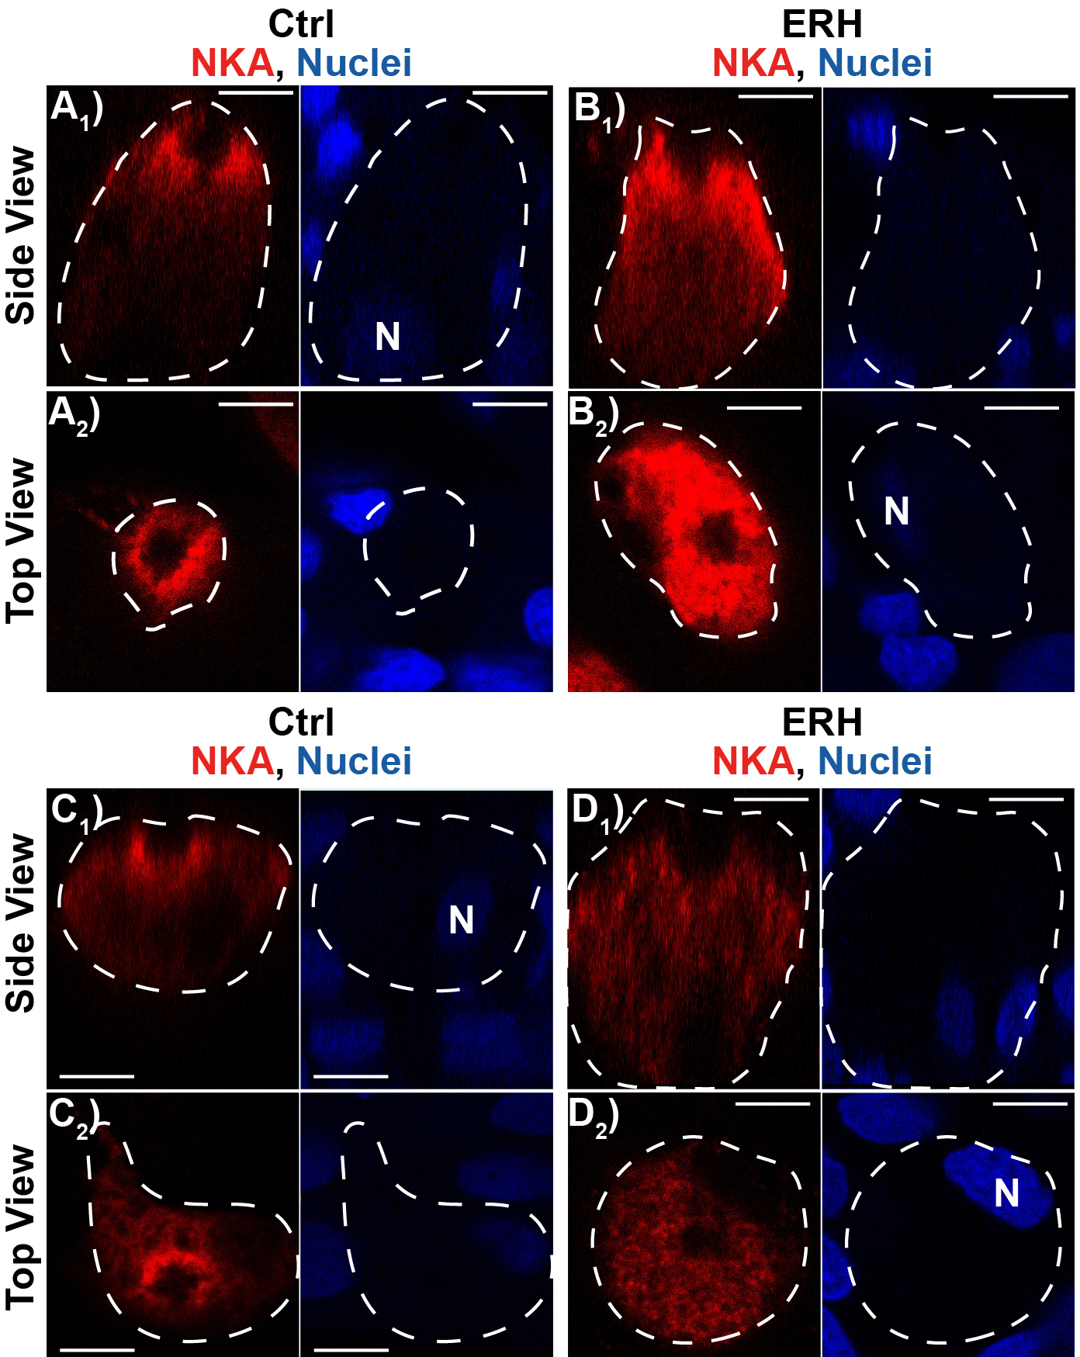

**Supplemental Figure 5**: **Protein localization in gill NKA-rich ionocytes from control and ERH rockfish.** Na+/K+-ATPase (NKA) and nuclei (N) expression within NKA-rich gill ionocytes after exposure to A, B) control (ctrl) or C, D) environmentally relevant hypercapnia (ERH) conditions. A1-D1: confocal images along the side view (*XZ* plane);A2-D2: confocal images along the top view (*XY* plane). (n>5 per protein, per treatment). White dashed line indicates the boundary of the NKA-rich ionocyte, which were determined with transmitted photomultiplier (T-PMT). Scale bar = 5 μm.